
While doing the sound meditation, I felt that I was guided by my own soul and I experienced the silence, the power and calmness inside me.
Shahana.

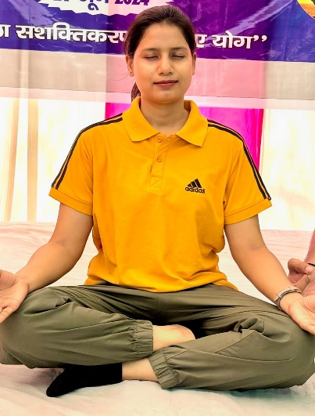
“When you guided us into the sound meditation, It felt like a deep sense of stillness and relaxation, along with a feeling of being connected to the universe in some way.”
Priyanka.

Dear Varsha,
Namaste 🙏🏻
Thank you for guiding me through such a

peaceful meditation session under the Bargad tree near JECP. It was a truly calming experience. Those few moments allowed me to embrace a sense of nothingness, creating much-needed space for myself. It is rare for me to enter this transitional phase, and I deeply appreciate the opportunity to do so. Your presence and guidance made the experience even more meaningful.

Grateful for the peaceful moments we shared.

Warm regards, Dr Suvarna Pise – Tapkir


Your yoga session inspired me a lot and I got to learn a lot . I felt that meditation is very important for healthy health. I got to Understand How sound affects us by creating healing vibrations , The sound meditation was very peaceful…….thank you, Soni.

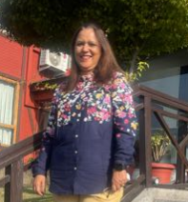

“Meditation under the Bargad tree is very
auspicious and the positivity was further
enhanced by Varsha through her ability to
ensure that there is an amalgamation of
soul with the environment “ .
Thx a ton Varsha.
Vibha

